**CN LAB REPORT**

**(RA2211026050065)**

A brief explanation of each key network parameter (IMEI, MAC, IP, etc.) and its importance. (Note: write your understanding without directly copying from AI-generated text)

* Screenshots from the Field Test Mode display the required information.
* Your grades will be based on your understanding, creativity, and the level of AI-generated content or plagiarism.

**IMEI:**

Every mobile device is given a unique 15-digit code called the International Mobile Equipment Identity (IMEI). By assisting mobile networks in recognizing and following devices, it provides security features such as the ability to blacklist stolen or lost devices, thereby preventing them from accessing the network.

**MAC Address:**

Media Access Control Addresses are a special way to identify the network interface card of a device. In LANs (local area networks), it enables security features like media access control (MAC) filtering and allows devices to be recognized within a network (e.g., Wi-Fi or Ethernet).

**IP Address:**

Devices on a network are uniquely identified by their IP addresses, which enable data to be routed between them. It allows devices to link up over local and global networks and also acts as a location identifier.

**MSISDN:**

The mobile phone number associated with a SIM card is called the MSISDN, which stands for Mobile Station International Subscriber Directory Number. In a network, it is crucial for subscriber identification and for sending messages or phone calls to the right device.

**IMSI:**

One piece of information that helps verify a user's identity on a mobile network is the International Mobile Subscriber Identity (IMSI), which is kept on a SIM card. Because it uniquely identifies the subscriber across all networks, it is essential for roaming services and precise billing.

**DNS:**

Domain Name System (DNS) translation of human-readable domain names into Internet Protocol (IP) addresses is the last step. By eliminating the need to memorize numerical IP addresses, this process facilitates easier internet navigation by directing users to the appropriate web resources.

**Screenshots:**

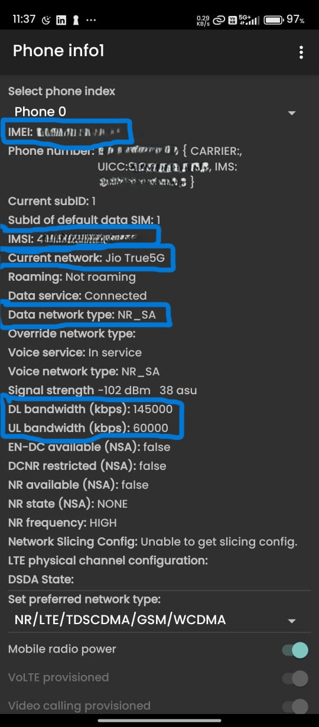

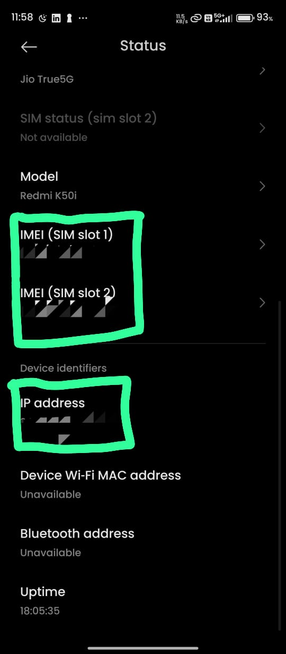

Name: Rayean Patric F

Class: CSE AIML B

Year: III

Reg.No: RA2211026050065

Github Link: <https://github.com/rayeanpatric/RA2211026050065>